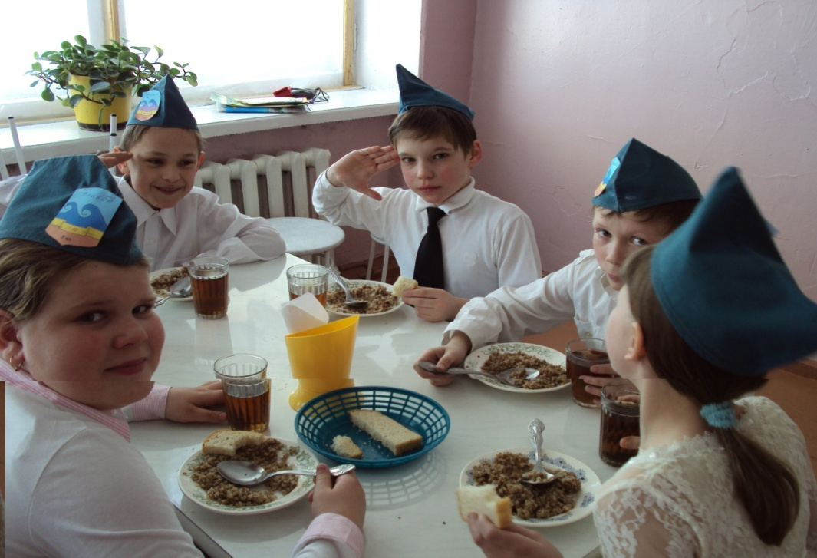
PROJECT

My Schoolmates
Done by:
Sergei Kucher
Form 7
2011
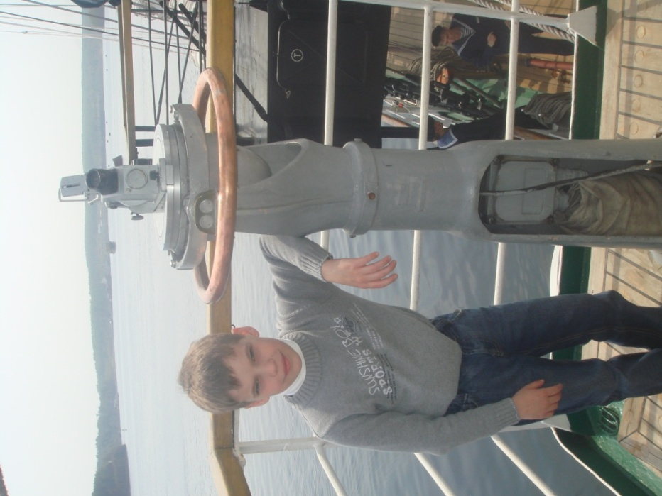
Acquainted.
It’s me.

The quickest
learner.

The dreamer.

It is Vlada. It is Leonid
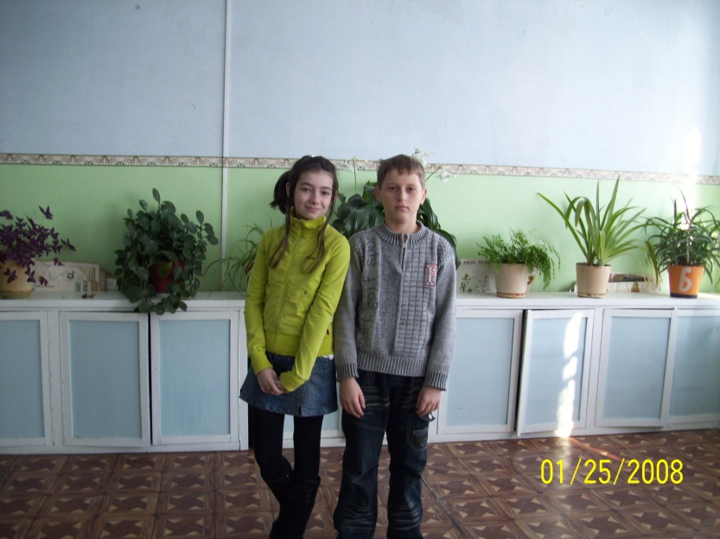

She studies well. He goes in for sports.
He is the volleyball player.

It is Tolya.
He is a master of all trades
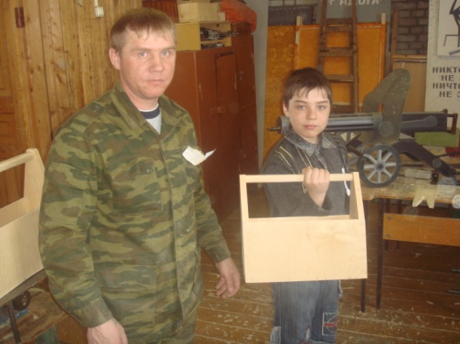

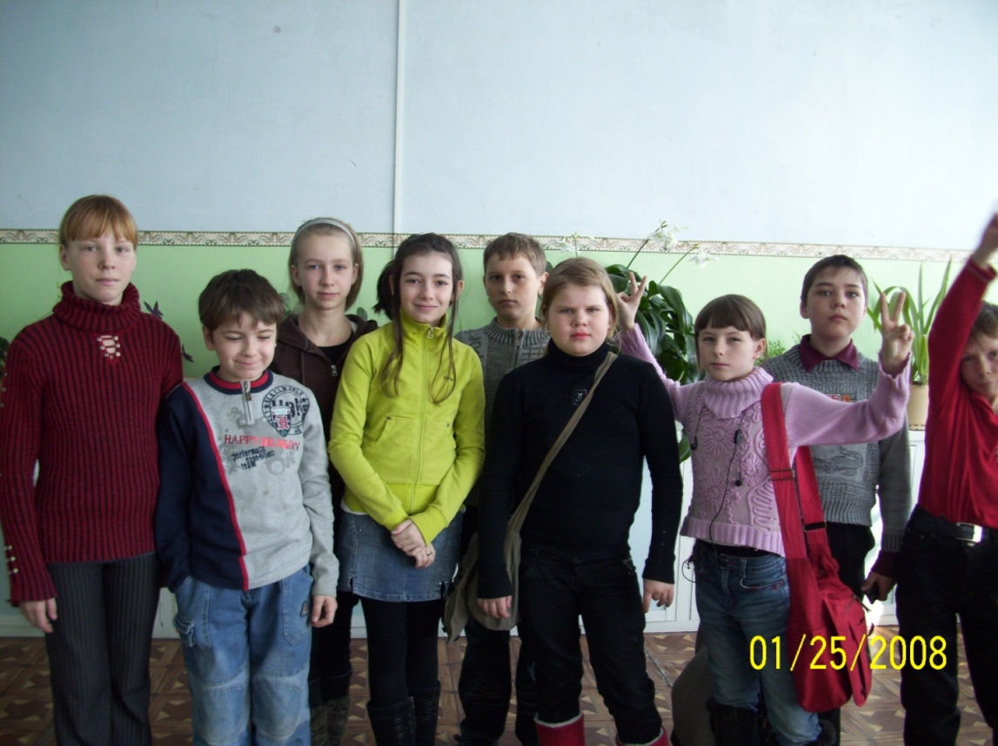

It is Kristina - the loudest shouter
in our class.

It is Ira.
She is engaged in dances.
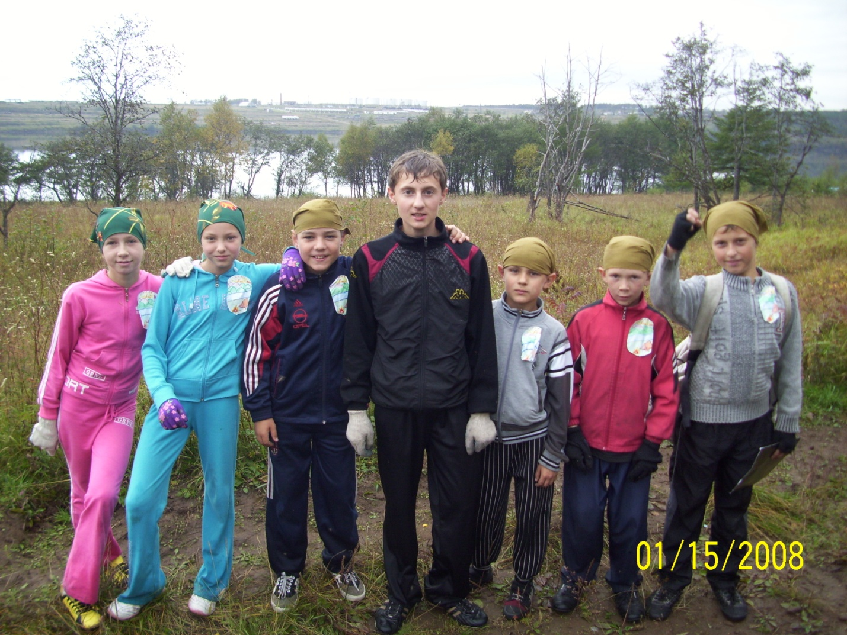

It is Sergei.
It is my friend.

It is Nadya.
She draws well.

