Project

«The Board of Fame of Our Class»



Done by:

Anna Kvashnina

Form 7

The fastest runner – Vanieva Veronica

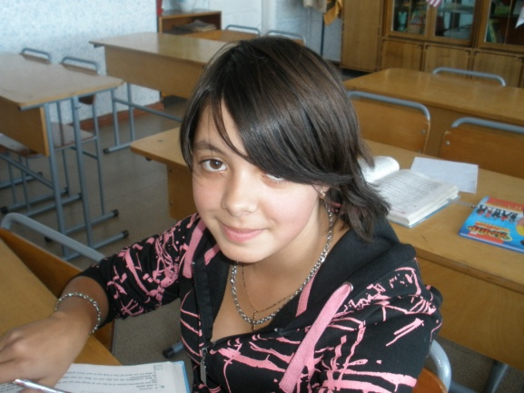

The loudest shouter – Korotkov Sergey

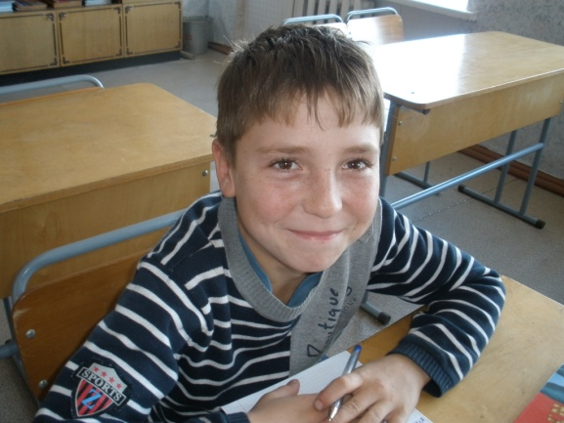

The hardest worker – Noskova Julia

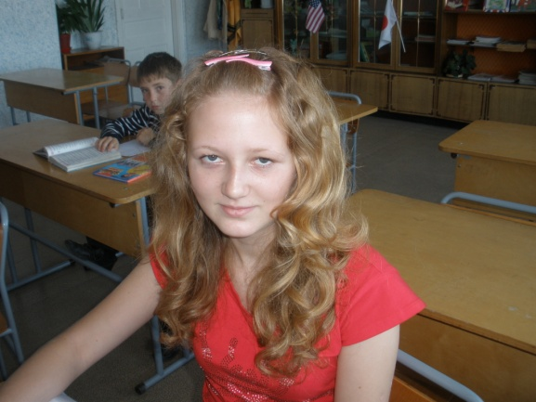

The quickest learner – Sumin Ivan

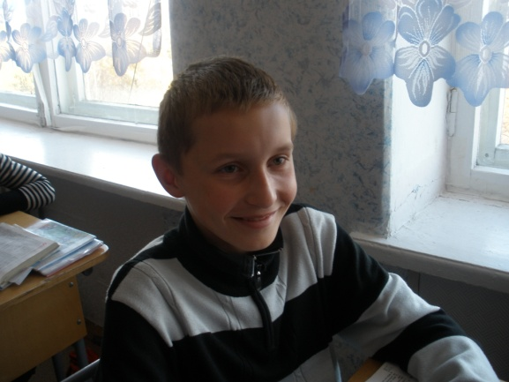

The funniest storyteller – Demidova Alina

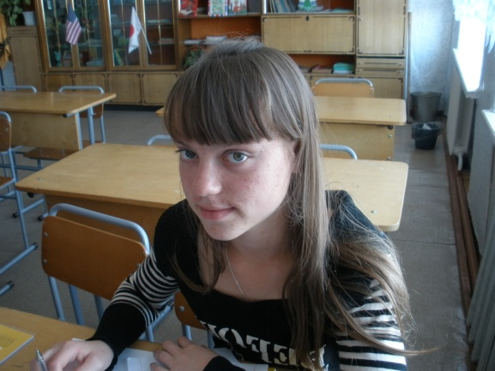

The best househelper – Pestryakov Dmitriy

