*Project*

*Season activities*

**

*Done by: Vlada Kolesnichenko*

*Form 6*

*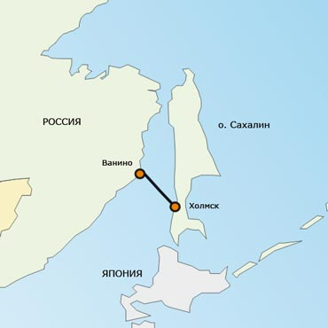 Winter Spring*

*Vanino Vanino*

*-15 Holmsk -5 Holmsk*

*-12 0*



*Summer* *Autumn*

*Vanino Vanino*

*+15 Holmsk +3 Holmsk*

*+18 +5*

**VANINO**

Coordinates 18px-Erioll_world[49°05′00″ northern latitude 140°16′00″ eastern longitude﻿ / ﻿49.083333° northern latitude 140.266667°](http://toolserver.org/%7Egeohack/geohack.php?language=ru&pagename=%D0%92%D0%B0%D0%BD%D0%B8%D0%BD%D0%BE&params=49.083333343333_N_140.26666667667_E_type:city%2818500%29_region:RU_scale:200000)  eastern longitude

Time zone [UTC+10](http://ru.wikipedia.org/wiki/UTC%2B10), [летом](http://ru.wikipedia.org/wiki/%D0%9B%D0%B5%D1%82%D0%BD%D0%B5%D0%B5_%D0%B2%D1%80%D0%B5%D0%BC%D1%8F) [UTC+11](http://ru.wikipedia.org/wiki/UTC%2B11)

Telephone code +7 42137

Post code 682860

Web-site: [www.vanino.org](http://www.vanino.org)

[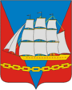](http://ru.wikipedia.org/wiki/%D0%A4%D0%B0%D0%B9%D0%BB:Coat_of_Arms_of_Vanino_rayon_(Khabarovsk_krai).png)Vanino is a settlement of a city type, the center of Vanino district of Khabarovsk Territory and the port on the Tatar Strait. **Vanino is called Russia’s gateway to the Pacific.**

**History**

Vanino district was formed in 1973. It is situated on the shore of the Tatar Strait and occupies an area of 25,000 sq.km. The first settlements on the territory of the present-day Vanino district were registered in the 19th century. They were inhabited by the local people – the Orochis.

Vanino Bay was put on the map in 1874 by an expedition led by Boltev. The Bay was named after Ivan Vanin – member of this expedition. The previous name of Vanino was Tishkino.

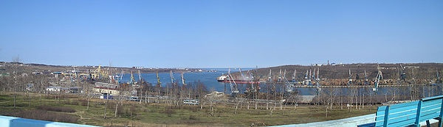

**Economy and Development**

The District has the deposits of gold, tin, copper, titanium, zinc and other resources.

**The leading sector of our economy is transport**. First of all, it is the Vanino Commercial Sea Port – one of the largest ports in Russia which operates round the year, has a container terminal, 20 berths and is capable of handling up to 11 mln tons of cargoes a year. And a coal terminal of JSC Daltransugol with the 12 mln tons of annual capacity. Transport sector also includes a railroad line, a ferry to Sakhalin Island, the Vanino-Khabarovsk highway, and oil’s transshipment, fulfilling by Transbunker. The second largest sector of Vanino’s economy is forestry. Main enterprises are Vega, Arkaim, Tairiku, etc.

**The next major sector is fishing**. Crabs, salmon, other marine resources are being tapped.

Vanino has a splendid potential for economic development and attraction of investments.

Now Vanino has excellent opportunities for the development of it’s economy due to the construction of coal terminal, and for the development of tourism due to it’s nature.

**The Tumnin springs** are popular with the inhabitants of not only the Russian Far East but with the people living in other areas of Russia and CIS (Commonwealth of Independent States) countries.

There is a Palace of arts, including a Community Center, a children’s arts school, a family circle library and an Art Gallery in Vanino. Vanino’s dance group “Monica” and ensemble “Sudarushka” – are very popular even abroad.

There is the Church of St. Nicolas in Vanino.

There is yacht and amateur flying clubs in Vanino and of course our Palace of Sport with the swimming pool.

In 1993 there was signed between the towns of Vanino and Ishikari (Hokkaido, Japan) an agreement on establishing sisterly relations. Both in Vanino and Ishikari were created Russian-Japan Friendship Societies.

**Climate & Weather**

The climate is a temperate monsoon. Winters are mild and snowy, while summers are cool and rainy. There are frequent fogs on the coast of Tatar Strait and the Vanino Bay.

|  |  |  |  |  |  |  |  |  |  |  |  |  |
| --- | --- | --- | --- | --- | --- | --- | --- | --- | --- | --- | --- | --- |
| **Average sea water temperature** | | | | | | | | | | | | |
| **Jan** | **Feb** | **Mar** | **Apr** | **May** | **June** | **July** | **Aug** | **Sep** | **Oct** | **Nov** | **Dec** | **Year** |
| **−1,6 °C** | **−1,6 °C** | **−1,3 °C** | **0,0 °C** | **3,0 °C** | **6,6 °C** | **9,8 °C** | **13,3 °C** | **13,2 °C** | **9,2 °C** | **4,2 °C** | **−0,5 °C** | **4,5 °C** |

Winter in Vanino is usually cold and windy. People wear warm clothing, such as down-padded coats, fur-caps, warm boots. Winter activities are rather different: skating, skiing, sleighing. Winter fishing is also very popular.

Spring in Vanino is early and prolonged. People usually wear cloaks, windcheaters, rubber boots.

Summer can be described as not hot and foggy, so you can swim and bathe in the sun only in August.

Autumn is very warm & beautiful. Season clothing includes jeans, windcheaters, raincoats. One can walking along the seaside and going mushroom-berries-nuts-picking in the forest.

Have You ever been in Vanino, dear guests?

Let us invite You to our place.  **Welcome!**